

CLIENT: | Thelen CDJR | PHONE #:
SPOT: | THEL-CD-T201001 Ram Power Oct | FAX # : | Sept Ram Spot
LENGTH: | :30 | SALES REP: | Larry H.
DATE: | 10/5/2020 | PRODUCER | A. Dennis

GRAPHICS | Video | AUDIO
Thelen Chrysler Logo  Euclid Ave. - Bay City  www.thelenchryslerjeepdodge.com  (Chrysler, Dodge, Jeep, Ram Logos)  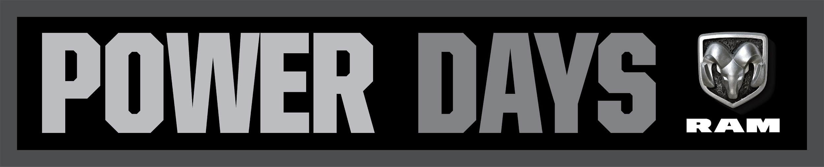  2021 Ram 1500 Big Horn Crew Cab  Lease From Just $199 /mo  Lease for 36 months, 10,000 miles per year for qualified lessees with approved credit. $3,289 cash down, or trade equity total due. Tax, title, license, document fees extra. Must qualify for Chrysler Employee Pricing and all available incentives and rebates. See Thelen Chrysler for details. Ends November 2nd, 2020.  2021 Jeep Compass Limited 4x4  Lease From Just $169 /mo  Lease for 36 months, 10,000 miles per year for qualified lessees with approved credit. $3,095 cash down, or trade equity total due. Tax, title, license, document fees extra. Must qualify for Chrysler Employee Pricing and all available incentives and rebates. See Thelen Chrysler for details. Ends November 2nd, 2020.  Thelen Chrysler Logo  Euclid Ave. - Bay City  www.thelenchryslerjeepdodge.com  (Chrysler, Dodge, Jeep, Ram Logos) | GFX: 2020 Ram Power Days Logo  GFX: 2021 Ram 1500 Big Horn Crew Cab  GFX: 2021 Jeep Compass Limited | Announcer: (:)  It’s time to Think Thelen Chrysler Dodge Jeep Ram in Bay City!  Because you deserve more!  More power! More towing capacity! More savings!  And getting more comes standard with every new Ram Truck or Jeep at Thelen Chrysler!  During Ram Power days, lease a new Ram 1500 Big Horn from just $199 a month!  Or drive a new Jeep Compass Limited for just $169 a month!  Think Thelen Chrysler Dodge Jeep Ram - Euclid avenue, Bay City!  Getting you more for your money... because it’s the right thing to do!
Approved:_______ Approved with Changes: Client Signature: _________________________________

